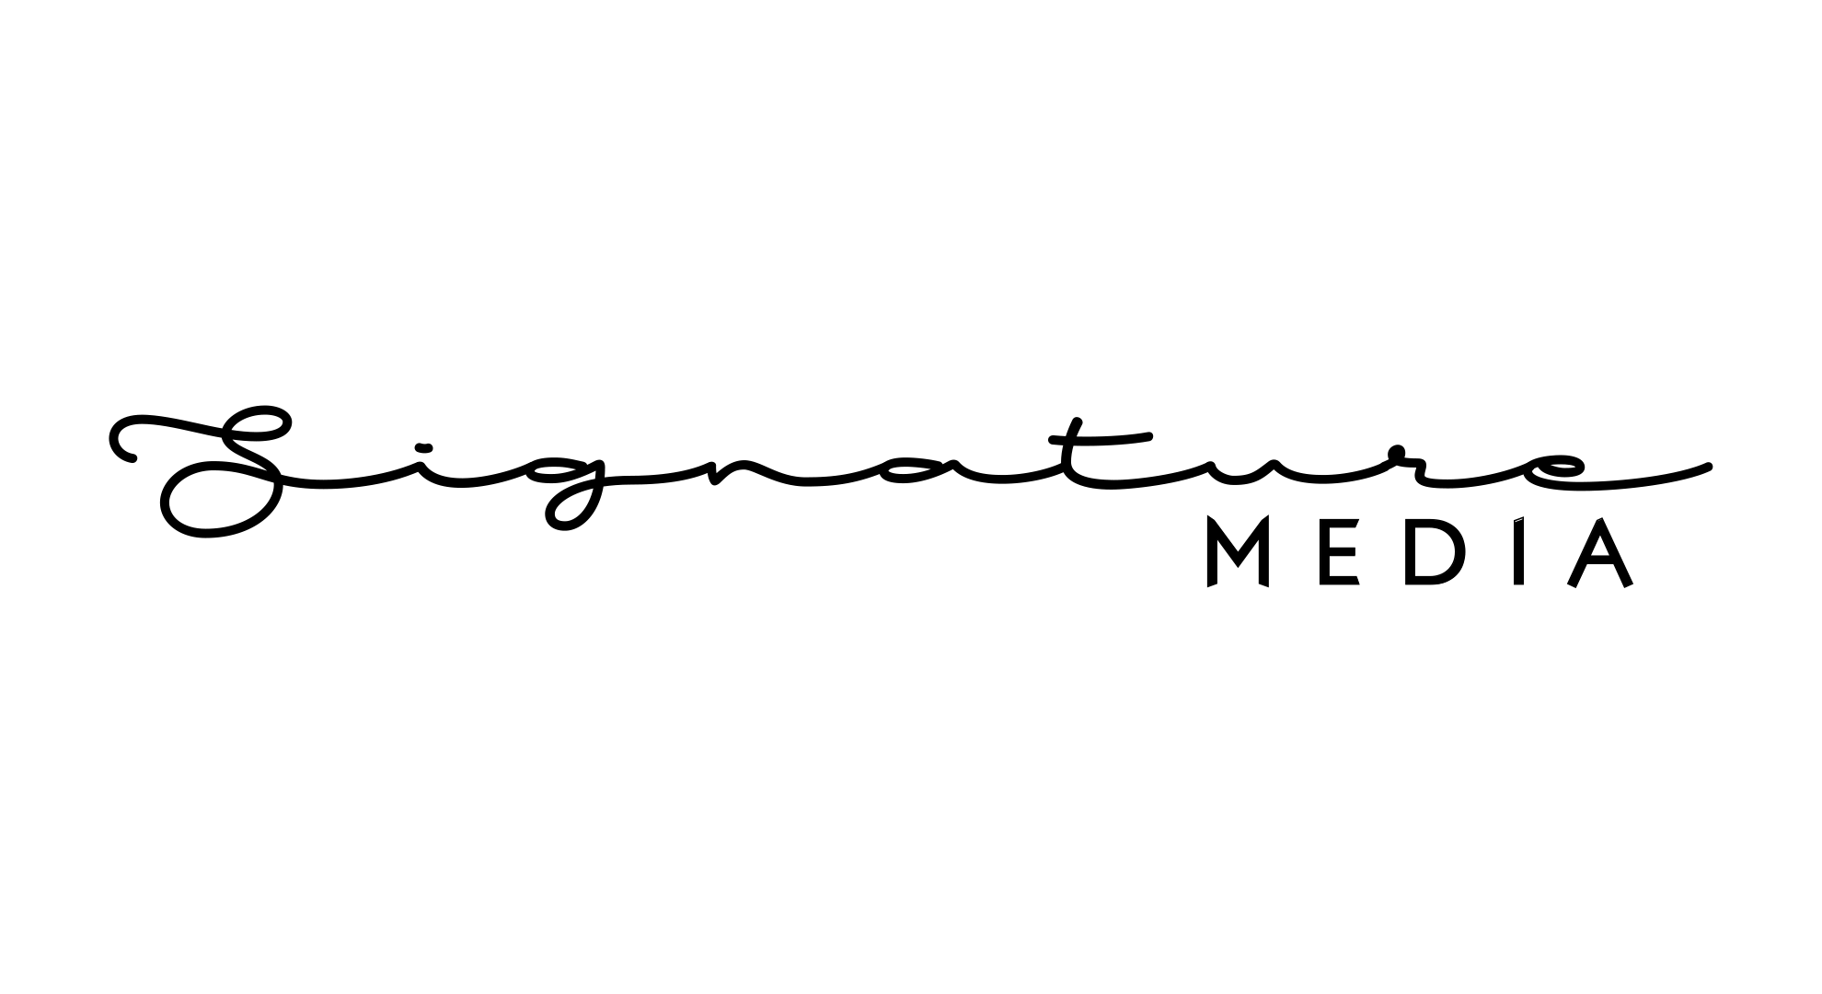

Groom & Bride’s Names
Email Address*
Wedding Date*
Phone Number *

* Please note that only 3 songs can be changed after the first draft is given BUT songs cannot be changed once again after 2nd draft.

Please complete your song list once You have completed the form Email Us back soon as possible so We can get started.
Please note that after you submitted Your Song list. You will receive your first draft after 3 months after you can make any changes.
Our Email Address info@signaturemedialtd.co.uk

Trailer Song
\\\\ Please note that Trailer Song CANNOT be CHANGED once given.
Second choice its optional.

Bride Entrance Song*
Second choice it’s Optional.

Groom Entrance song*
Second choice it’s Optional.

Bride Walk-Way to groom’s Stage Song
This will be Played when the Bride walks to the main stage.
Second choice it’s Optional.

Cake Cutting Song*
This song will be played when cutting the cake, Ring exchange, feeding milk and garland exchange on the wedding day.
Second choice it’s Optional.

Bride Getting Ready Song
Second choice it’s Optional.

Groom Getting Ready Song
Second choice it’s Optional.

Wedding Song List
Don’t Forget to add song name & Film name or Artists Name.
Have You book Us For Mehndi?

Yes or No.

If YES to previous answer NO just Submit

Mehndi Song List*
Don’t Forget to add song name & Film name or Artists Name.

End Credit
Please Supply Us with A Thank You Message

